1. Summary

The following points is the basic stats through data explore

* # Total Bets: 3,461,173 transactions
* # Total Event: 44 (1 Event cancel)
* # Total Account: 21,020 unique accounts(represent unique players) in 69 different countries
* # Total Matched bet: 2812898 with **81.2% of all trans** (high this point)matched rate
* # In play Bet : 2534654, with 73.2% of all trans **, for in play bet are all matched**(highlight this)
* # Total positive profits(can generate commission for Betfair) : $706,808,897
* # Total Loss (should approximately equal to total profits): $-706,823,612

1. Explore the Data(finding distributions and correlations)
   1. the distribution of bets made by accounts,

Most of accounts made transactions less than 50( about 71.67% of total accounts)

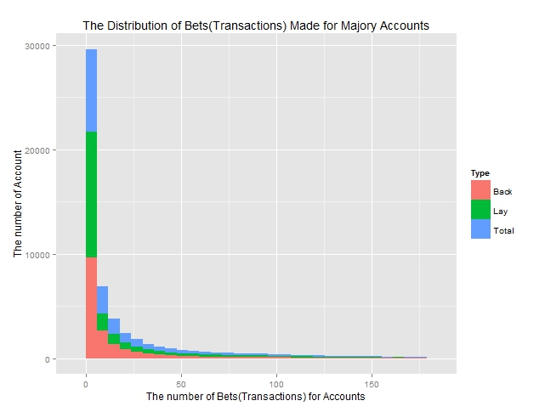

* 1. Correlation between the amount of money invested by customers and the profits (loss) for the customers. As can be seen from the plots, at the very beginning, net variance of net profit will increase by total money invested. However, in general, exclude the outliers(very lucky and very unlucky account), the amount of money invested can slightly affect the net profits.

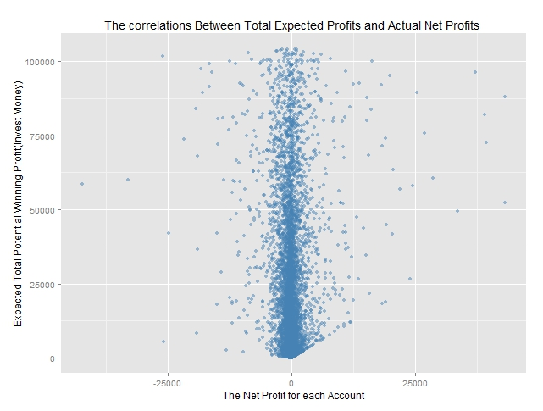

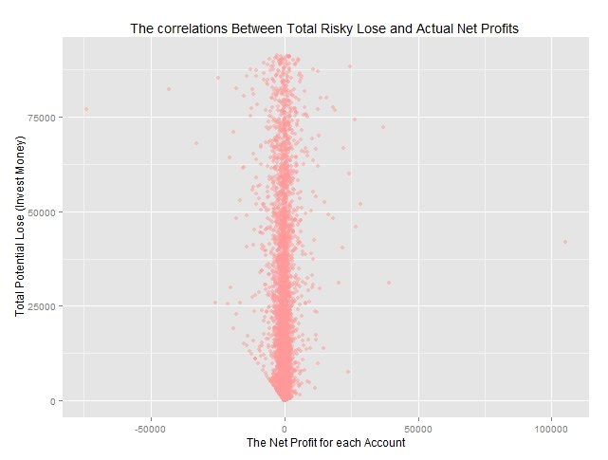

* 1. Average expected rate and Matched Rate: slight negative correlation

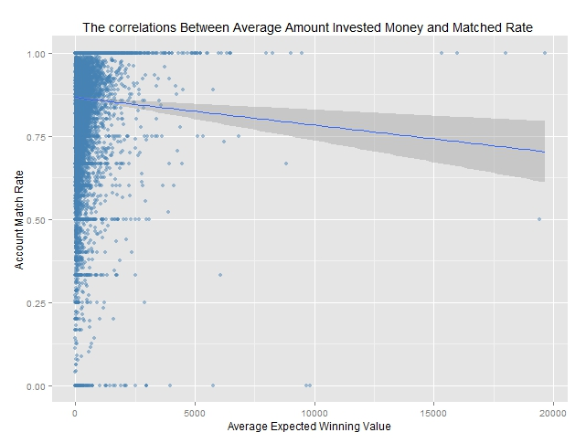

* 1. Correlation: Standard deviation of Invested Money on different event and Matched Rate: Negative

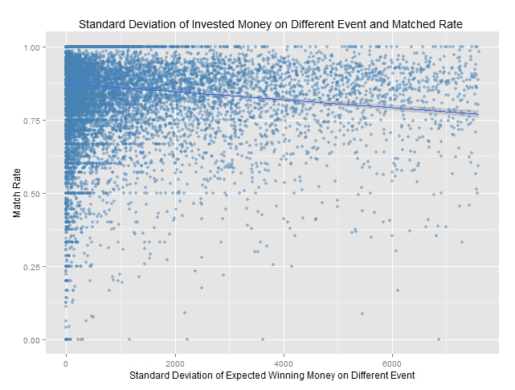

* 1. Correlation: Standard deviation of Bets made on different event and Matched Rate: Negative

